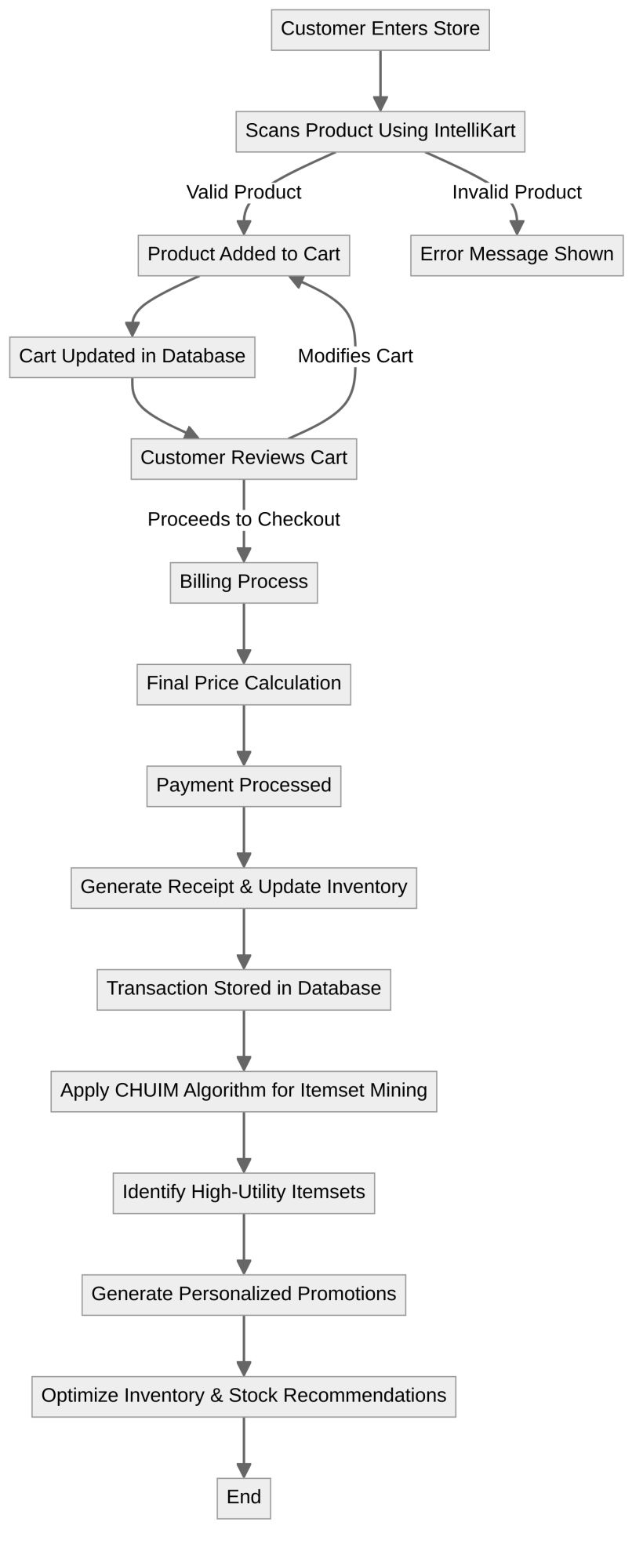

* **Customer Shopping Process:** The customer enters the store and scans products using IntelliKart. Valid products are added to the cart; invalid ones show an error message.
* **Cart and Checkout Flow:** The cart updates in the database. The customer reviews it, proceeds to checkout, and completes billing and payment.
* **Transaction and Inventory Management:** After payment, a receipt is generated, inventory is updated, and the transaction is stored.
* **Data Analysis and Optimization:** The CHUIM algorithm analyzes purchases, identifies high-utility items, personalizes promotions, and optimizes stock recommendations.

14

* **Software Calculations:**

**Algorithm Efficiency :** Develop CHUIM algorithm for identify High- Utility Itemset and also add QR code scanning, weight measurement, and billing calculations.

**Data Storage:** Determine the required storage capacity for product information, pricing, and transaction records.

**User Interface:** Design the user interface for the billing screen, considering ease of use and responsiveness.

* **Structural Calculations:**

**Weight Capacity:** Determine the maximum weight the cart can hold based on the material strength and structural design. This involves calculations for stress, strain, and deflection.

**Conveyor Belt:** Calculate the required motor power and belt speed based on the weight of items

and desired throughput.

**Cart Dimensions:** Optimize the cart's dimensions (length, width, height) to accommodate a variety of items while maintaining maneuverability. give mi bullet points but i have only 50 words

* **Electrical Calculations:**

**Power Consumption:** Estimate energy use for OR scanner, weighing machine, billing screen, and conveyor motor.

**Battery Capacity:** Calculate required battery capacity based on power needs and operating time.